**Supporting Maths At Home ~ Year 6 ~ Curriculum Link** **s ~ Summer Term**

**Revision & Maths Games Websites**

<https://uk.ixl.com/math/year-6>

<https://classroomsecrets.co.uk/category/maths/year-6/> (Some resources and games are free)

<https://www.bbc.co.uk/bitesize/subjects/z826n39>

<http://www.icteachers.co.uk/children/children_sats.htm>

<https://www.educationquizzes.com/ks2/maths/>

<https://www.mathplayground.com/math-games.html>



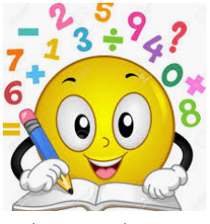

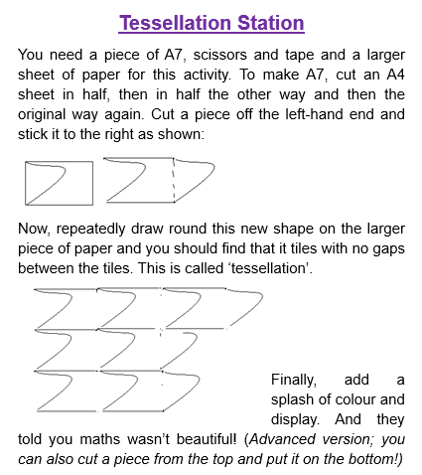

**Please continue to practice times tables at home using Times Tables Rock Stars (TTRS) or Hit the Button.**

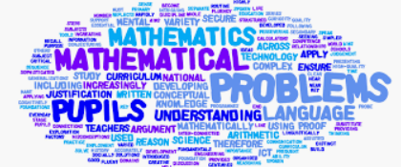

**Supporting Maths At Home ~ Year 6 ~ Just for fun…**

**Useful Websites**

Online games and videos to enhance Maths learning at home

* <http://www.amathsdictionaryforkids.com/>
* <http://mathszone.co.uk/>
* <https://www.bbc.co.uk/bitesize/subjects/z826n39><http://www.primaryhomeworkhelp.co.uk/maths/>
* <https://mathsframe.co.uk/>
* <https://nrich.maths.org/primary>
* <http://www.crickweb.co.uk/ks2numeracy.html>
* <https://www.topmarks.co.uk/maths-games/7-11>

