**Supporting Spelling At Home**

Year 6 Spelling Words

Some spelling tips for year 6:

**1. Encourage children to ‘have a go’ at spelling a new word.** Making a first attempt is good for confidence, and it can reinforce spelling patterns and help identify any problem areas.

**2. Make sure children remember to use their phonics as they try to spell a word.** Encouraging children to break the word they want to spell into its individual sounds and then try to match those sounds to the letters of the alphabet is really important. For older children it’s about making sure they keep this skill fresh. Reminding children to segment ‘catch’ into its three sounds – ‘c’ ‘a’ ‘tch’ – sounds like such a basic way of supporting spelling, but practising it is so important.

**3. Ask children to write down the words that they need to remember how to spell.** The physical act of writing the words by hand helps to anchor the spelling in children’s memories and encourages them to think about the letters that represent the sounds in the word. You just don’t get the same benefits if children type the words into a PC or tablet.

**4. Hidden words is a game that you can prepare yourself.** Write the words on your child’s spelling list, hidden in a series of letters. Now that they are hidden, ask your child to find them. For example:  
sfhplayknc – play

qrubitpdh – bit

nvzbikejfa – bike

Your child could circle the hidden words with coloured pens. To raise the challenge, you could set a time limit on the game. For example, how many words can you find in one minute?

**5. Making silly sentences can be great fun.** Challenge your child to write a silly sentence, including as many of the words on their spelling list as possible. For example, your child may have to learn ‘room, took, hoop, foot, book’. They could make up a silly sentence such as ‘The boy took his book across the room but got his foot caught in a hoop’. Again, they could draw illustrations to go with the sentences.

**6. Remind children to read through their writing and check for spelling errors.** They need to develop a feel for whether a word looks right. They could underline words they are not sure of and then you could both check with a dictionary.

**7. ‘Over-pronunciation’ is a great spelling strategy.** So for ‘Wednesday’ encourage children to say ‘Wed-nes-day’ as they write. There are lots of words which feature sounds that aren’t always pronounced clearly (such as words ending in -ed), so asking children to over-pronounce these when spelling can also be useful (for example, teaching children to say ‘hopped’ or ‘skipped’ instead of ‘jumpt’ can be a huge help).

**8. There are few resources more motivating than a highlighter pen for primary-aged children.** You can focus children’s attention on the tricky bits in a word by asking them to highlight them. For example, show them that receive has ‘ei’ in the middle and ask them to write the word, and then highlight or underline this part to help them remember.

Finally, remember that learning to spell is a gradual process and children need to go through this at their own pace. Children learn best at home when they enjoy what they are doing so try to keep spelling activities fun and lively. Enjoy!

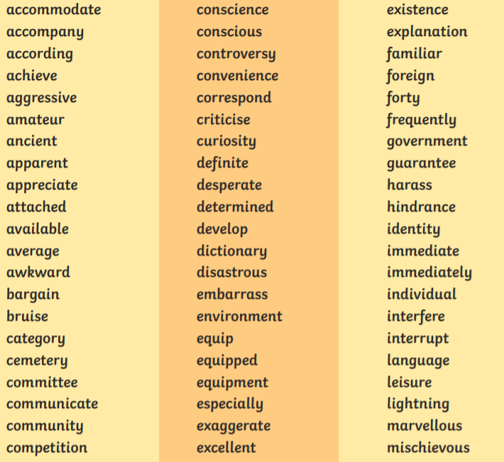

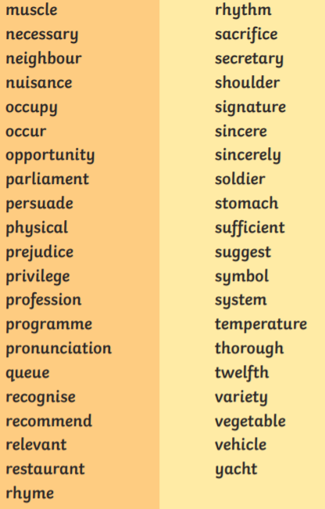



Some ideas for practicing spellings:

Websites to support spelling:

<https://www.topmarks.co.uk/english-games/7-11-years/spelling-and-grammar>

<https://www.spellzone.com/word_lists/games-368706.htm>

<https://www.learninggamesforkids.com/word_games/spelling-games/clueless-crossword.html>

<https://howtospell.co.uk/misspelled-words-quiz-1>

<https://spellingframe.co.uk/>

<http://www.crickweb.co.uk/ks2literacy.html>

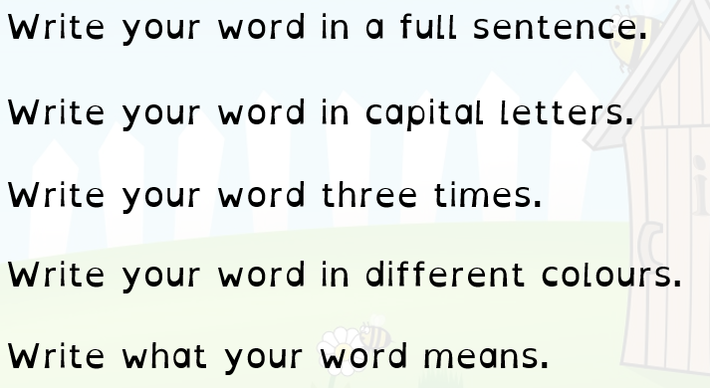

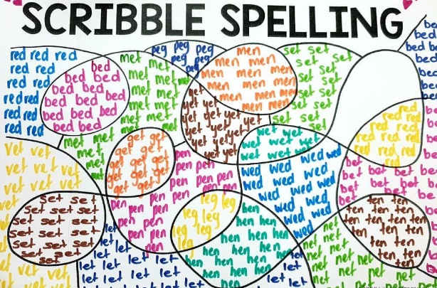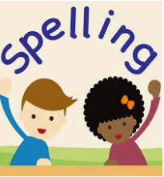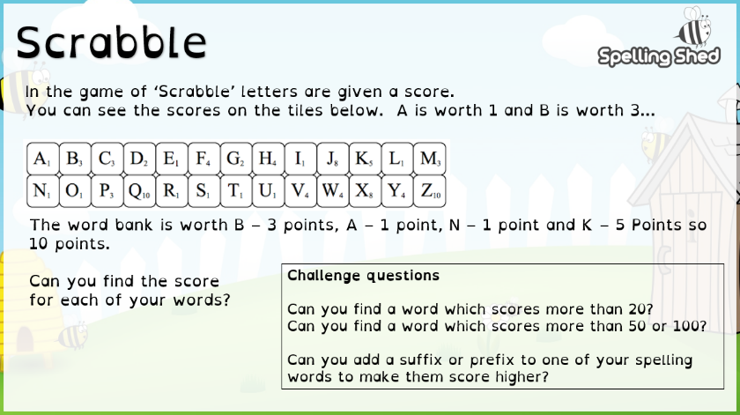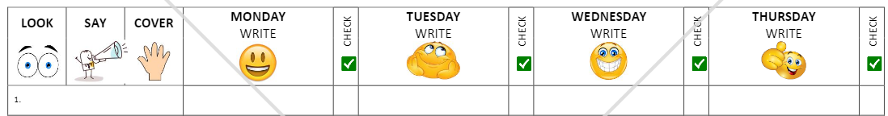

Look, Say, Cover, Write, Check!