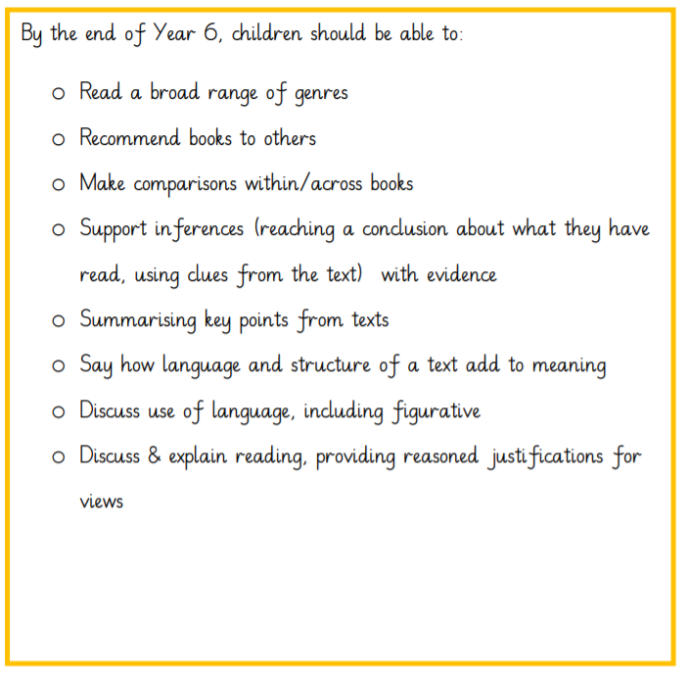**Supporting Reading At Home**

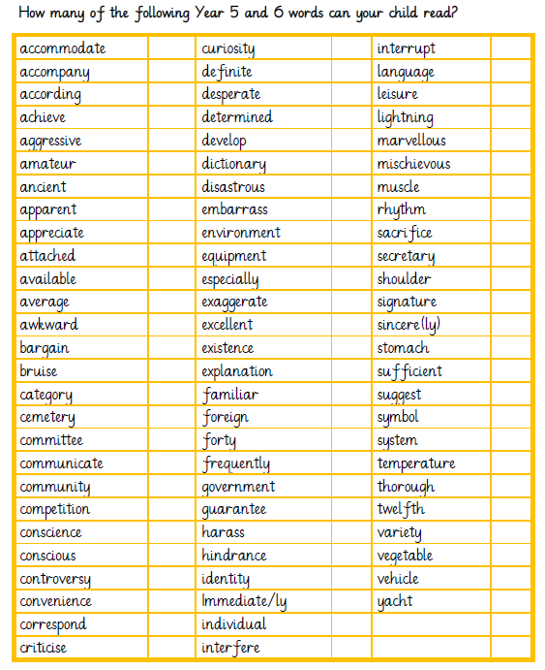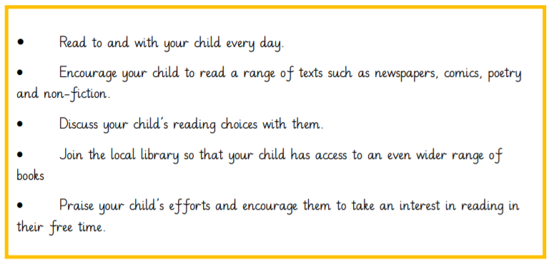

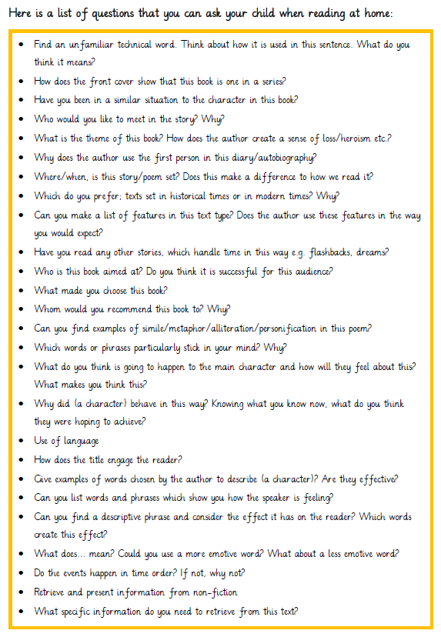

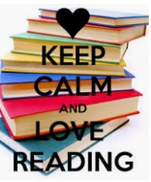

Finding a Book…

Help your child choose engaging books from a wide variety of types and genres: poetry, fiction and non-fiction, picture books, and non-book materials, such as magazines, newspapers, comics and graphic novels.

Children should choose their own reading material for independent reading. Children will not always get the choice right, but by making mistakes, they will learn to make correct judgements.

Other resources such as artefacts, recipes, reading games, ‘story sacks’ and audiobooks; ICT resources, such as computers and tablets, ebooks and online texts can be used to engage children in reading

Some reading lists for year 6:

<https://www.lovereading4schools.co.uk/lists/36/Year-6-age-10-11>

<https://www.booktrust.org.uk/booklists/1/100-best-books-9-11/>

<https://schoolreadinglist.co.uk/reading-lists-for-ks2-school-pupils/suggested-reading-list-for-year-6-pupils-ks2-age-10-11/>

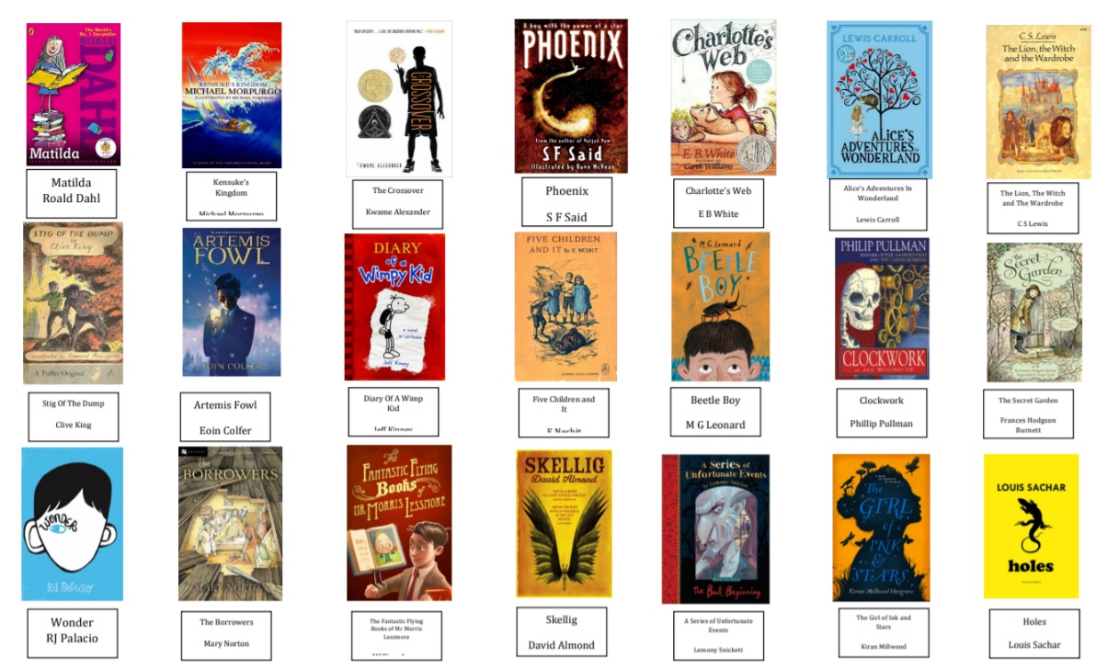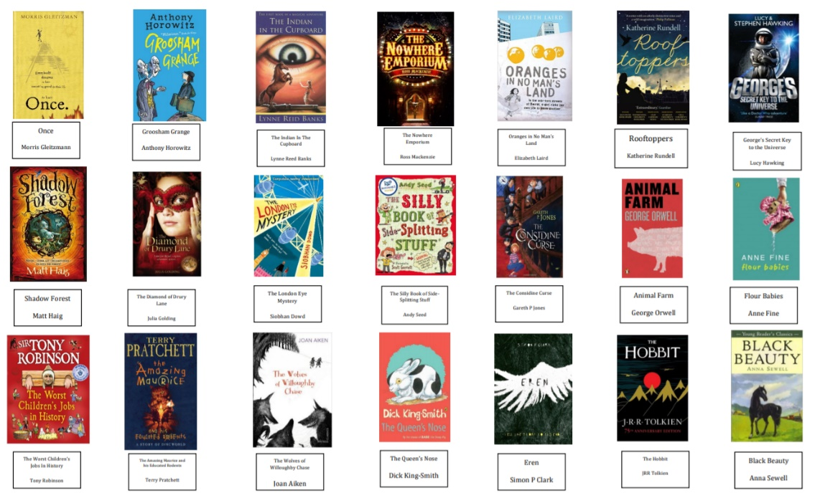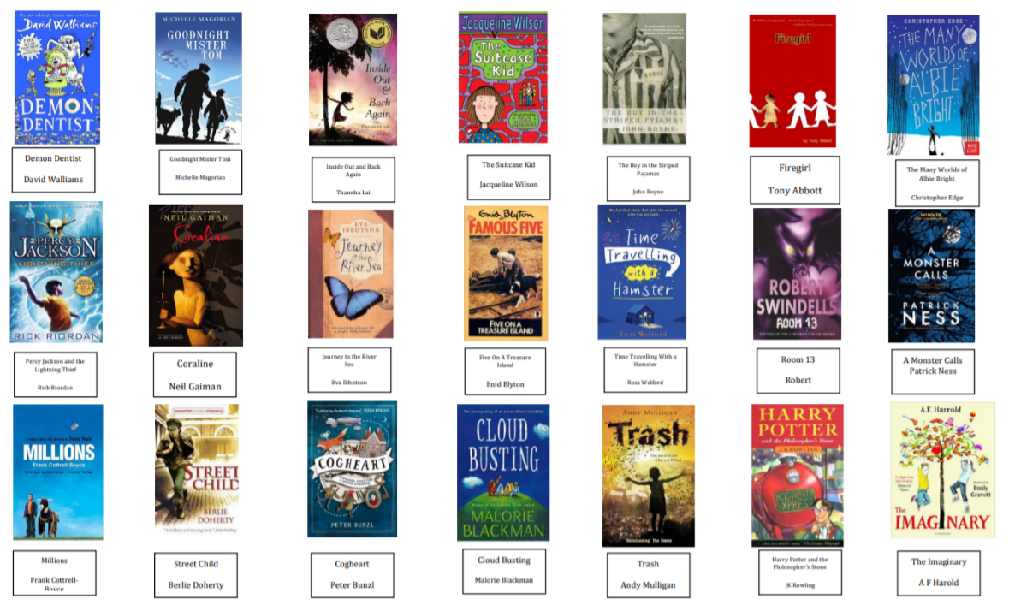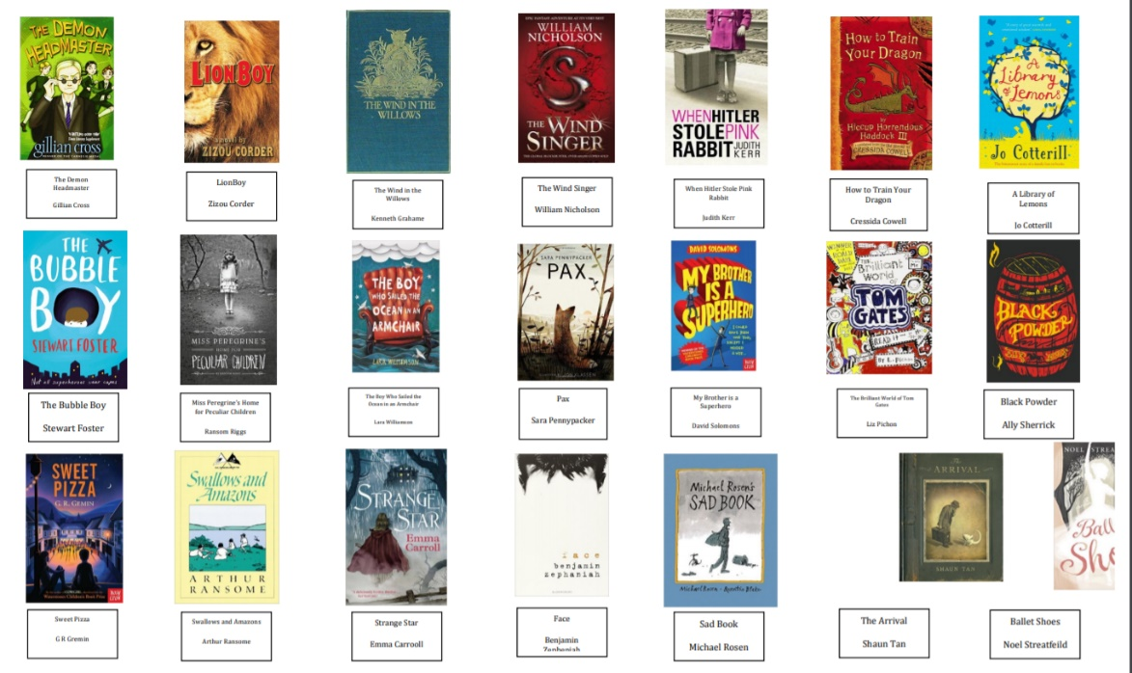

Some other suggestions for year 6…