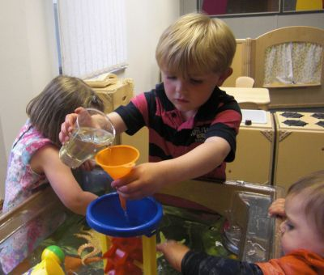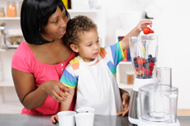**SHIELD**

**Maths Through Play**

**The EYFS approach**

St Paul’s C of E Nursery

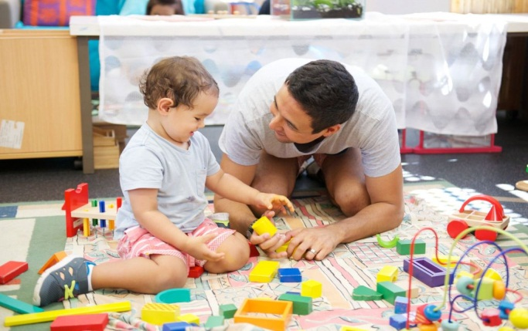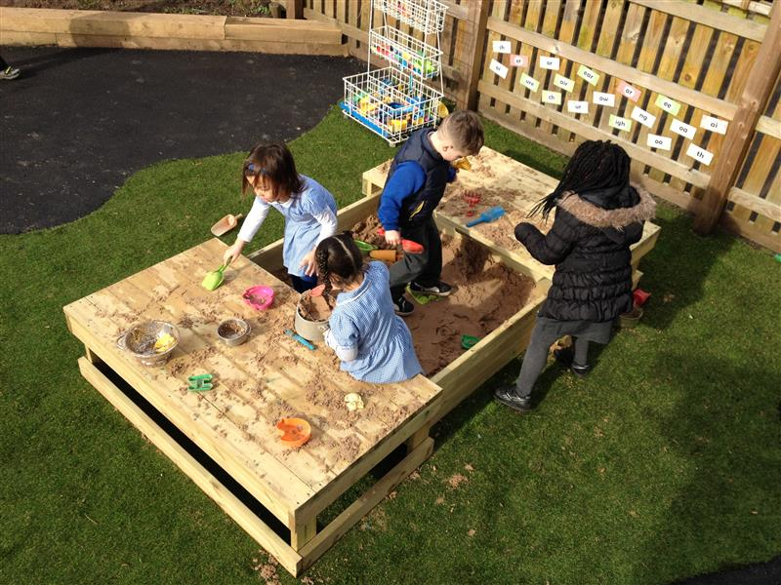

**SHIELD**

Maths is Everywhere!

Developing understanding of mathematical concepts in the EYFS is not achieved in a separate entity with children learning on a particular table in the ‘maths area’ each day. It is achieved through grabbing opportunities in EVERY activity in the setting each day. All play lends itself to aiding children’s understanding of a mathematical concept. From making our play dough in the morning to counting how many children we have left to go home at the end of the day, the children are immersed in a world full of maths in all that they do.

Grabbing these opportunities with children is essential for them to understand maths in its truest form and it gives their understanding of maths concepts context and depth.

Use life as your strongest early years teaching tool and you can’t go wrong!

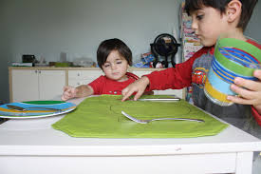Outings are also full of maths opportunities. Looking out for amounts of objects. Looking for numerals on doors or cars. Subitising natural objects or animals. Looking for natural opportunities for more or less, exploring money in shops and many more.

*The children can hardly help but be engaged by mathematics if they are surrounded by it! – Helen Williams*

**Maths in the routine**

Maths is everywhere in the home. With the support of parents, children can grasp many mathematical concepts through their play.

By using the opportunities below children will begin to:

• know and understand early maths language of measurement, shapes, spaces, positions, early numbers, order and patterns

• know the sequence of numbers

• begin to understand positional words, e.g. in, on, outside

• show an awareness of time

• be aware of shapes in their environment

• be aware of 1-to-1 correspondence

• acquire new vocabulary

• learn number rhymes and songs, e.g. one, two, buckle my shoe etc.

• be aware of conservation

Sorting out the clothes after the washing has been done and hanging them up.

Experiment with money when shopping

Tidying up their toys after playing. Sorting, ordering, matching.

Cooking – weighing, counting out spoonfuls.

Learning about the concept of time by understanding what happens and when each day.

**The value of a number**

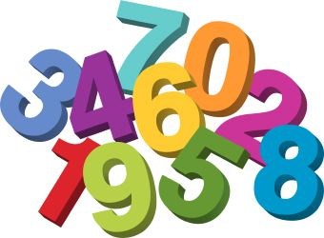

[This Photo](http://teacherrose1964.blogspot.com/2011/03/cicle-inicial-segon-numbers.html) by Unknown Author is licensed under [CC BY-NC-ND](https://creativecommons.org/licenses/by-nc-nd/3.0/)

When we say a child “knows his/her numbers” what we often mean is that she can recite the names of numbers in ascending order. This is quite useful to be able to do, but it means very little in itself. Children need to come to know what the number system really means. They can be helped to do this through play. One of the first things they have to learn is about conservation – that 3 is always 3 no matter how it is arranged or presented, whether it is the number 3, the letters for three, 3 bricks, 3 buttons on a coat or 3 Billy Goats Gruff. Before a child can understand numbers for things that can’t be seen – 3 miles, 3 years old – s/he needs real objects which can be seen and handled with a chance to check that the count is right each time.

This understanding is so important before children can then begin to use numbers. Any form of reinforcement of the value of numbers is a vital stage in development. This can be achieved by counting in books, counting when going up the stairs, sharing out many sweets/grapes etc. This repetitive use of number in their routine can really help to affirm a child’s understanding of the value of each number giving them a more concrete understanding of the number system and how numbers work when beginning calculations. To make this concept even remotely accessible to the children it has to be practical and exploring the conservation of number (that the amount of ‘3’ will always remain the same no matter how it is organised) will benefit their later understanding of how the numbers then change when more or less are added.

**The development of counting**

**The order of the stages of understanding when children learn to count**

1. Sorting and categorising – Sorting objects by size, colour etc.
2. One to one correspondence – Pointing at and counting still objects one by one and knowing when the count starts and ends.
3. Counting objects that can be touched and moved – the oneness of one.
4. Count immovable objects – understanding strategies to count objects accurately that can’t be moved.
5. Conservation of number – That a value is always that value if nothing is added/taken away no matter how the number is presented.
6. Instantly recognizing an amount without needing to count. Familiar patterns of up to 6 objects – subitizing.
7. Develop strategies to count a larger number of objects

A few useful links

<https://www.bbc.co.uk/cbeebies/shows/numberblocks> - The value of numbers

<https://www.topmarks.co.uk/Interactive.aspx?cat=139> – Number rhymes

<https://www.bbcgoodfood.com/recipes/collection/kids-cooking> - Children’s recipes

<https://theimaginationtree.com/best-ever-no-cook-play-dough-recipe/> - Playdough recipe

<https://www.pinterest.co.uk/cathyjames/bath-time-play-activities/?lp=true> – Bath time maths

*Let’s not simply ‘do’ maths, but ‘live’ maths with our children! – Michael Jones and Jude Twani*

1. Estimating.