**NURSERY Spring Term Letter**

**January 2025**

We are so excited to welcome our new children to St Paul’s Nursery! For those returning after a fun and relaxing Christmas break, we are so pleased to have you back and can’t wait for another wonderful term together.

**Topics and Learning**

This half term, our topic is *Winter Wonderland*. Through this theme, the children will explore the wonders of winter – both in our own country and around the world. We will learn about animals that live in snowy habitats, including those in the North and South Poles, as well as how people dress for cold weather and the exciting activities winter brings.

Our hands-on explorations will include playing with ice, pretend snow and snowy small-world scenes, sparking discussions about freezing, melting and the changes we observe. Winter will also come to life through books, stories and songs, helping the children develop new and exciting seasonal vocabulary.

As part of our outdoor learning, we’ll look for signs of winter in the Wonder Woodlands. We have already experienced real snow, ice and frost in the garden, giving the children valuable first-hand experiences of the season - we hope to see more in the coming weeks!

We will also dedicate a special week to learning about birds inspired by the *Big Garden Bird Watch* from the RSPB charity. Through this, the children will discover different bird species, their habitats and unique features, all while engaging in fun, hands-on activities. We’ll even explore shadows using bird shadow puppets, adding a creative and scientific element to our learning.

Another exciting highlight will be our week-long celebration of Chinese New Year. This will be a fantastic opportunity for the children to learn about global festivals and cultural traditions. The week will be full of dancing, singing, creating and even a chance to taste Chinese food – making for an immersive and enriching experience.

After half term we will move onto our *Spring* topic, exploring the seasonal changes that come with this time. The children will learn about the process of planting and growing, spring time animals and flowers. We’ll also learn about Easter, focusing on both the Christian traditions and other family customs, as well as exploring Easter celebrations around the world.

Additionally, we’ll dive into the vibrant Holi Festival, the Hindu Festival of Colours that celebrates spring, love and new life. This is always a favourite experience, filled with colour, imagination and opportunities to be creative on a large scale.

We can’t wait for all the exciting learning, discovery and fun that this half-term has in store!

**Absences**

**If your child is absent for any reason, please call the School Office on the same day to inform us, as this is important for our records. If your child has had sickness or diarrhoea, please keep them at home for at least 48 hours after their last episode to help prevent the spread of illness.**

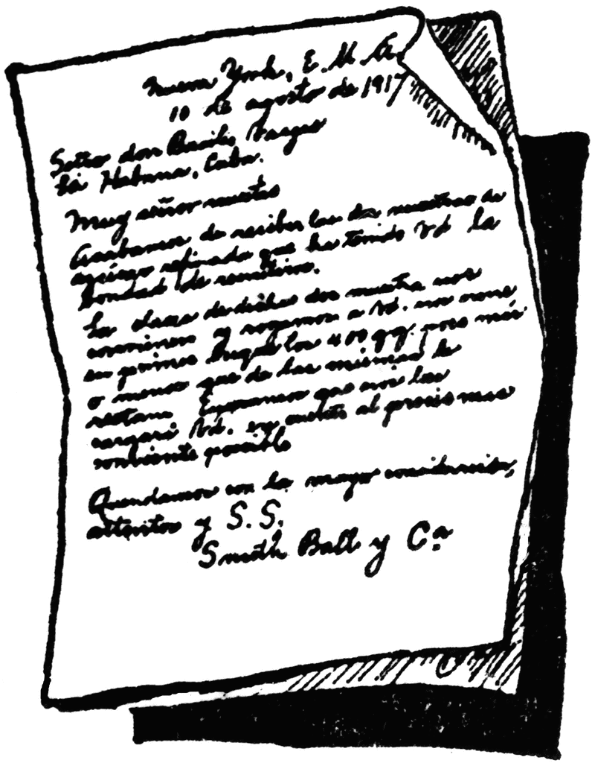

**Picking up reminder**

**If someone else will be picking up your child at the end of the day, please inform the School Office via email. If it is someone we have not met before, a password must be provided to both the person collecting and us to ensure the handover is secure.**

**Lunches**

**If your child is staying for lunch, please make sure any food provided is free from nuts, sesame seeds, pesto and hummus. As a nut- and sesame-free school your support is essential in helping us to keep the children safe.**





Classroom Dojo

We have now set everyone up on Class Dojo and are receiving some wonderful photos and updates from our families, showcasing the activities children are enjoying at home. We would like to encourage all families to share their child’s learning and experiences with us so we can celebrate them in Nursery. If you need any help using the app to upload photos and videos to your child’s profile please don’t hesitate to ask – our staff will be happy to assist. You are welcome to share anything with us; it does not have to be linked to our home learning suggestions. We will continue to provide home learning, which will now be sent out on Tuesdays. This will include a weekly phonics update to support your child’s learning at home, along with additional ideas to enhance our topics. We look forward to seeing and sharing more of your children’s wonderful experiences.





**Mystery Reader and Super Story Sessions**

**This term we are excited to continue our Mystery Reader sessions! These were a great success last term, and the children loved the excitement of discovering who would be reading to them each week. It was wonderful to see them engage with different readers and enjoy a variety of stories.**

**Due to the children’s enthusiasm, we will be holding the Mystery Reader sessions weekly. We are happy to be flexible with dates and times, so if you would like to take part, please email, call or speak to a member of the team to arrange a suitable time. The children especially love it when their own parent is the Mystery Reader, so we encourage you to get involved!**

Additionally, this term we will be holding two Super Story sessions where parents can come in to hear a member of the Nursery team read a story to the children. More details will be with you shared soon.

**Writing Stay and Play – Save the Date**

Our next Stay and Play session will take place on **Tuesday 11th March from 8.45am – 11.00am** with a focus on early writing. This session will provide families with fun and engaging ways to support children as they begin exploring letters, early mark-making, and letter formation when they are ready.

We hope this session will give you useful ideas to try at home, as well as a better understanding of the approaches we use to support early storytelling and large mark-making.

We hope you will all be able to join us! A letter with more details will be sent out soon.

**Key Vocabulary**

Here are some key vocabulary words related to our *Winter* topic for the first half of the term. We encourage you to use these words as often as possible at home during play, walks and story time to help reinforce them in a meaningful context. The more exposure children have to these words, the more easily they will learn and remember them.

Our first set of key vocabulary focuses on winter and snow. The Nursery team will be using these words regularly during play and activities to support the children in learning and confidently using them.

**glistening sparkling crisp frosty bare**

**slushy slippery freezing thawing blustery migrate**



Wonder Woodlands

This term our Wonder Woodland session will move to Thursday afternoons. If your child attends Nursery on this day, please ensure they have wellies, warm clothes and waterproof overalls to keep them comfortable in all weather conditions. As most of the afternoon will be spent outdoors, we also recommend thicker socks to help keep their feet warm when they are wearing wellies.

These sessions provide valuable hands-on learning experiences, encouraging curiosity, problem-solving, independence, communication and language development through the exploration of the natural world.

This half term, we are excited to introduce new activities, including the use of simple tools and basic outdoor cooking to further enrich the children’s experience. We look forward to giving the children these exciting new opportunities and hope they enjoy developing their skills in the outdoors.